**Revision Work Sheet on the Essays**

**Question 1. Directions:  Read the story.  Then fill in the chart of causes and effect**

Jeremiah, Jasmine, and their parents had wanted to visit the beach for years. Consequently, the entire family has been doing their part to earn extra money. Jeremiah gets up early on weekends, so that he can deliver newspapers. Jasmine has been able to help some of their neighbors with lawn care and housekeeping. The children’s dad has been watching sale items and saving a lot of money on their weekly grocery shopping. Mom has also worked hard to clip coupons, which saves the family about $20 per week.  Not to mention, the family has reduced their eating out habits to only one per week, which saves them about $40 per week. If the family can keep this up, they are bound to have their toes stuck in the sand this summer.

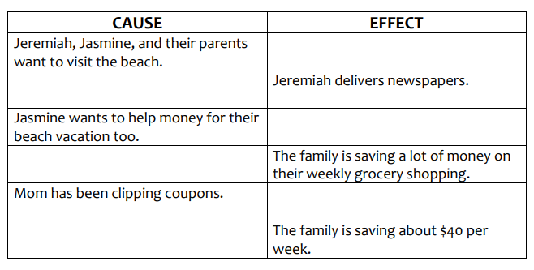

**Question 2. Write cause and effect for the following after reading the text.**

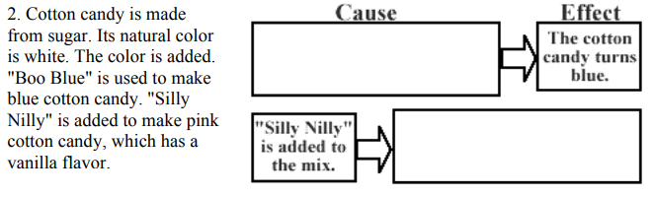

**Question 3. DIRECTIONS: Following are the short written descriptions about grandparents. Read each paragraph. Then fill out the Venn Diagram below to compare the two.**

**Grandma**

My grandma is quite a character. She spends her mornings tending her beautiful flowers in her garden. Then, she spends her afternoons painting pictures of her beautiful plants and flowers as well as the insects, birds, and animals that visit her garden. In addition to tending her garden and painting, she finds time to cook some of the best cakes and pies that you have ever eaten. She does all of this with a smile on her face and humming her favorite song. On a normal day, the only time you will find her sitting down is when she is sitting at her easel painting or eating a meal. Any other time, she is busy doing something. She loves it when I come to visit and enjoys spending time telling me about the old days and all the fun she had as a kid. Although she is 40 years older than I am, I have a hard time keeping up with her. She is a bundle of joy and energy.

**Grandpa**

If you want to know how to relax and enjoy life, Grandpa is the man to teach you. I don't think I have ever seen him in a hurry or too busy to stop and talk to anyone that comes to visit. You can usually find Grandpa sitting in his rocking chair on the front porch petting his old hound dog, Billy. If he is not in his rocking chair, then you can bet that he is at the pond sitting patiently in his boat, holding a fishing pole, and waiting for the fish to bite. Since Grandpa retired, he doesn't believe that life should be stressful, but should be enjoyed at a leisurely pace. When I visit Grandpa and Granma, it is the best of both worlds. I enjoy working alongside Grandma, but it sure is nice to sit on the porch and talk to Grandpa or spend the afternoon sitting in the boat with him fishing when I am too tired to keep up with Grandma. He enjoys telling me about when he was a kid, and I enjoy listening to his tales.

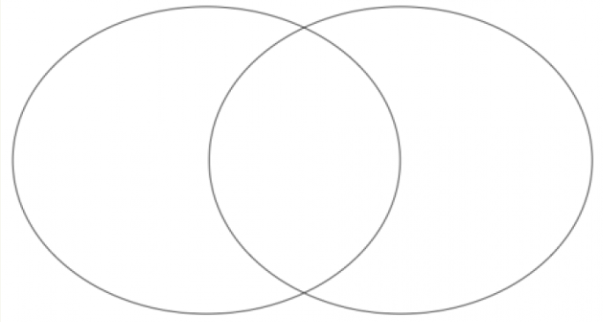

**Question 4. Problem solution essay: Linking problems with solutions**

*In order to solve this/these problem/s… One answer is……… A second/third/final answer is…. In order to overcome this/these problem/s… One solution is……… A thing we can do is….*

**Using the language above or your own ideas write solutions to the problems below**

1 Problem University dormitories are too noisy. Solution ____________________________________________________________________________

2 Problem Students are addicted to technology.

Solution ____________________________________________________________________________

3 Problem Some people find it difficult to sleep a t night.

Solution ____________________________________________________________________________

4 Problem A friend of mine is always unhappy.

Solution ____________________________________________________________________________

5 Problem My brother is always spending too much money.

Solution ____________________________________________________________________________

6 Problem The roads around here always have traffic jams.

Solution ____________________________________________________________________________

7 Problem My classmates don’t study hard enough.

Solution ____________________________________________________________________________

8 Problem The weather is really miserable.

Solution ____________________________________________________________________________

**Question 5. Directions: Take a position on the following topics and create a hook for a persuasive/argumentative essay. Also, write a strong thesis statement on the back of this page.**

1. Should the driving age be raised to 18?
2. Should anyone under 21 need parental approval to get married?

**Question 6. DIRECTIONS: Write a counterargument for each claim on the back of this page.**

1. Students should be allowed to celebrate their birthdays in school.

2. Students should be able to vote on where to go on field trips.